COLORADO SPACE DAY 2008 Part 2

The Denver Space Society (a chapter of the National Space Society) invites you to attend.

A day long event celebrating spaceflight and space exploration. This event is free and open to the public.

Saturday November 1st, 2008; 9:00 A.M. to 5:00 P.M.

Olin Hall – Room 105 (Denver University)
2190 East Iliff Ave.; Denver, Colorado

Speaker Schedule:
9:30 am to 10:30 am – Karl Henriksson – The Next 50 Years in Space 11:00 am to 12:00 noon – Bennett Rutledge – The Geography of Space 12:00 noon to 1:00 pm – Lunch Break 1:00 pm to 2:00 pm – William Murtagh – NOAA Space Weather Prediction Center 2:30 pm to 3:30 pm – Brian Enke – Mars Society and 4:00 pm to 5:00 pm – Space Shuttle ASTRONAUT Joseph Tanner

For more information, please call Bill Nelson at 303-330-2888, or go to our website at www.angelfire.com/space/frl5/
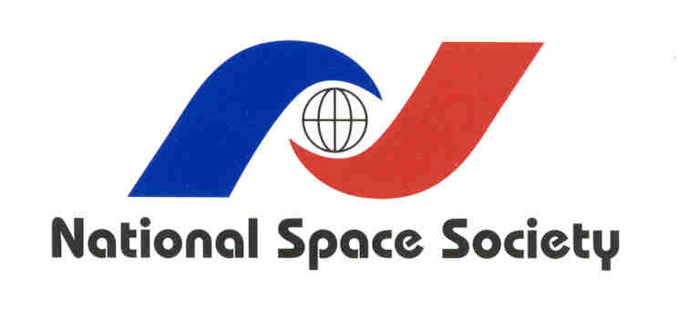
The Denver Space Society is a local chapter of the NSS
(Speakers Subject to Change without Notice)

