After Dark in Allenspark by Leslie Young
This month, let's meet the star "Ed Asich." Wait until its dark enough to see all seven stars of Big Dipper — Ed's about as bright as the the star where the handle's attached to the bowl. Starting from the last two stars in the handle of the Big Dipper, make a triangle that's two and a half times longer than wide. Ed's at the point of that triangle. Ed may be faint, but Ed's special. Ed has a planet.

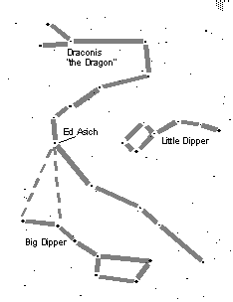
How do we know Ed's got a planet? It's not by seeing the faint planet directly, but by seeing how it knocks Ed off-center.
A big planet (10 times more massive than Jupiter) orbits Ed. Ed tugs on the planet, but the planet tugs on Ed a little too, so both Ed and the planet orbit around an imaginary point called the "center of mass." Ed is about one million times more massive than its planet, so the center of mass is almost at Ed's center, but shifted a little bit toward the planet. This means that when the planet goes around Ed once every 18 months, Ed wobbles around this off-center point once every 18 months too. And when the planet is screaming away from us at a fast billion miles an hour, Ed is creeping toward us at a sedate 1000 mph. (Why 1000 mph? Because 1 billion mph/1 thousand mph = 1 million = mass of Ed/mass of planet).
So, to find the planet, you look at the light from the star. When the star moves toward us, the light from the star is shifted slightly to the blue, and when it moves away, the light's shifted slightly to the red. Looking for planets this way is called the "radial velocity method," and astronomers have been finding planets around other stars this way since 1995. As of this June, they've found about 100 stars with other planets found around them, but Ed Asich is the brightest one of those so far.

