First light!
Like a ship's maiden voyage, a play's opening night, or a boyfriend's meeting of the parents, there are moments when you bring everything together for the first time and hope it all works. In astronomy, "first light" is that moment when you put a new camera on a telescope and first take actual images of the night sky.
My brother and I got first light with our new portable cameras and telescopes on a cold Sunday night last month. During the day of November 21, the forecast was poor, calling for snow. But at 8 PM, the sky was only partly cloudy, so I drove down to my brother's house in Boulder to set up our system in his driveway.
(Our telescopes and cameras are new tools we are putting together to learn about solar system objects by watching them pass in front of stars and measuring how the starlight flickers and fades. But more about that next summer!)
With cloudy skies and a quarter moon high in the sky, we tried observing Orion, rising in the East in a relatively clear area of the sky. Besides, Orion is one of the most prominent constellations in the winter sky. You can see him yourself this month, rising near twilight and reaching his highest in the South near midnight. The line of three moderately bright stars in his belt are easy to spot, as are his broad shoulders (one of which is bright red). Orion is a large constellation. From the left shoulder to the right foot, he is as wide as your splayed hand held at arm's length.

Hanging from Orion's belt is Orion's sword. One of the "stars" in the belt is not a star at all but a stellar nursery. This is the Orion Nebula, a cloud of dust and gas, looking like a fuzzy glow in binoculars. In the center of the Orion Nebula is a cluster of young stars called the Trapezium, where new stars are still being born.
For sound scientific reasons (we wanted several stars with different brightnesses on one image) and because this cluster is really cool, we took our first-light pictures of Trapezium. Here it is. The width of the picure is about a tenth of a degree, or a tenth of the width of a finger held at arm's length.
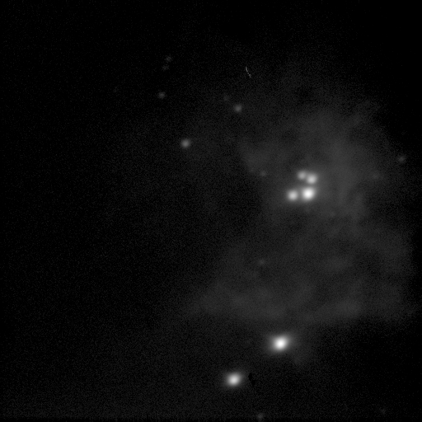

We packed up the equipment around midnight with cold fingers and light hearts. We hit no metaphorical icebergs, flubbed no lines, stepped on no parent's cat. A surprisingly smooth first light.

